**Placements of students in the job industry: An analysis of the key factors.**

It is true that most of the students are anxious about their future. After completion of the study, some start-up their business whereas must of the student seek job placement. Due to the tough job market, students are curious about what parameters are key to get a job placement. If you are about to graduate and is seeking the answer to the question of what key factors affect the placement, then you are at the correct blog. In this article, we will delve into the key factors that affect your job placement.

**Questions:**

1. Does gender affect placements?

2. Which board students have higher placement and who got a higher package?

1. Does the board of education affect salary?

4. Does Higher Secondary School affect Placements?

5. Does the percentage in college determine salary?

**Does the board of education affect salary and placement?**

There is a common notion among people that the board of education affects the salary. Those students who graduate from the top tier university get good placement, which ultimately translates to a high salary whereas the students who are graduated from the lower tier university or college do not get a proper salary. Nevertheless, the most important aspect is the skill sets.

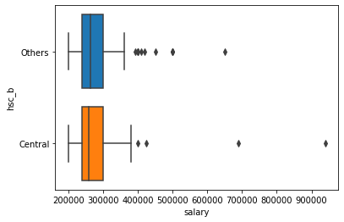

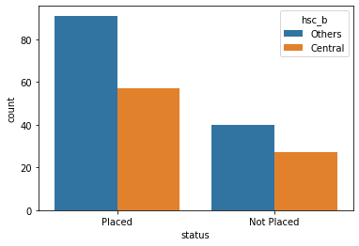

Our visualizations show that there is no difference in the placement of the students, whether they pursued their education in the central university or any other university and colleges. Likewise, from the boxplot, we can see that there is no much difference in the salary of the central and other colleges or universities. However, the central university has outliers who exceeding limits and bounds of the mean salary. But the number of other universities/colleges has more number of outliers.

**Does higher percentage determine salary?**



The high percentage in college is an important indicator of doing better in the academic career. However, does a high percentage translates into a better salary in the career field? The topic itself is a topic of moot. However, after doing some statistics and visualizing the data, we can see that a higher percentage in college or university does not translate to a higher salary. Nevertheless, we can see that those who score more than 65 percent earn a higher salary. However, an overall higher percentage is not a limiting factor for the salary.

**Does higher secondary school percentage affects placement?**

Placements after completing degree is a huge achievement for the graduates. Many people believe that a graduate should have overall good percentage to achieve good placements. Among that, higher secondary education percentage is also a key factor.

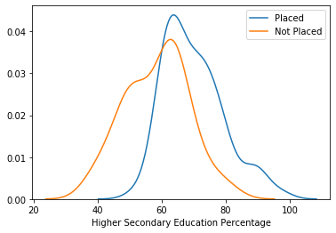

We have visualized the data to know whether the higher secondary percentage make much impact to in the placement or it’s just a words of mouth from the majority of people. The visualization shows us that there is a overlap between the placed and not placed students. We can observe that the students who secure more than 65 percent get better placement, whereas the graph plummets for the students who secure less than 60 percent in the higher secondary education.

**Conclusion**

From the above visualizations, we can conclude that the salary does not depend on percentage and the higher secondary education but students who score percentage above 65 percent are more likely to get jobs than those who scoreless percent.